**PROBLEM**

**Case Study - Heat Grid**

Victor, the head of creative team of a "Creaters Edge" wants to develop a web page which would display the heat grid chart comprising of the detailed ratings of all the events managed by the company for analyzing the statistics. The heat grid chart is highly useful in representing the collected information for the management purposes.  
  
Hence, the creative team has assigned you to create a web page which represents the percentage of the events on each date for a period of time in the heat grid chart format using the HTML and CSS concepts.  
  
**Content :**  
h1 tag - EVENTS & PROMOTIONS  
p tag - Our company's core objective is, simply but, to be good. Built on the principles of transparency and accountability, we work dedicatedly on designing be spoke solutions that are creative, feasible, efficient, meticulously planned and successfully implemented. We offer a range of solutions from product launches, gala dinners & conferences to theme nights, fashion shows, hostesses & models. Our events team handles all your requirements from conceptualization to execution, leaving you free to focus completely on achieving your objectives. With proper planning and logistics management and the ability to activate requisite resources, we have undertaken a wide variety of projects. Our professional operations team will manage every aspect of your event, from invitations and RSVPs, branding, sound, light and technical solutions, to local and international entertainment and event staff. With dedicated suppliers in place we are able to handle any event requirement our clients may have. Our specialized promotions department specifically focuses on providing clients with promoters, hostesses and models for marketing campaigns, events, exhibitions and fashion shows. We provide complete services covering selection, casting, training, supervision and reporting. We intricately craft each and every proceedings of your wedding , be it a Christian nuptials or a Hindu vivaha or a Muslim nikkah. Our experts have hands on experience in bringing your dreams to life , right from wedding cards design till the return gifts to the guests. Wedding is your day to indulge in pure love and happiness..Don't make it the day for your peak of tensions and hassles. We, as the leading wedding planners in the town ,listen to and understand your budget and expectations on your princess's wedding.Your dream will be brought to reality with at most care under your own budget.And what else, free your mind from tensions..Just stretch out and watch your princess joining her hands with her prince, with a happy and tension free face.  
div tag

Insites :  
The Higher rate of Bridal Party celebrations are made on January 3rd.  
The Engagement parties has an increased progressing ratio on January 15th.  
The Catering Services has a good raise in aspect ratio this month especially on January 12th.  
The scale of Wedding Ceremonies has increased this month mainly on January 14th.  
The Wedding Receptions also have a progressing ratio this month, majorly on January 13th.  
  
**Constraints :**  
The file name must be index.html.  
Refer screenshot for html specifications.  
The count of 'img' tag in your page must be 5.  
The images were given in the template code.  
The background color of each td varies based on the percentage.

For 0 - 20%, use background color- #fb3521 for td  
For 21 - 40%, use background color- #fa9348 for td  
For 41 - 60%, use background color- #f5ae20 for td  
For 61 - 80%, use background color- #e0e010 for td  
For 81 - 100%, use background color- #8fc60e for td

Content should be the same as given in the problem content.  
  
**Note :**   
The web page should be present as shown in the screenshot.  
Kindly refer the content which is given as a part of description.  
  
**Sample Screenshot 1 :  
  
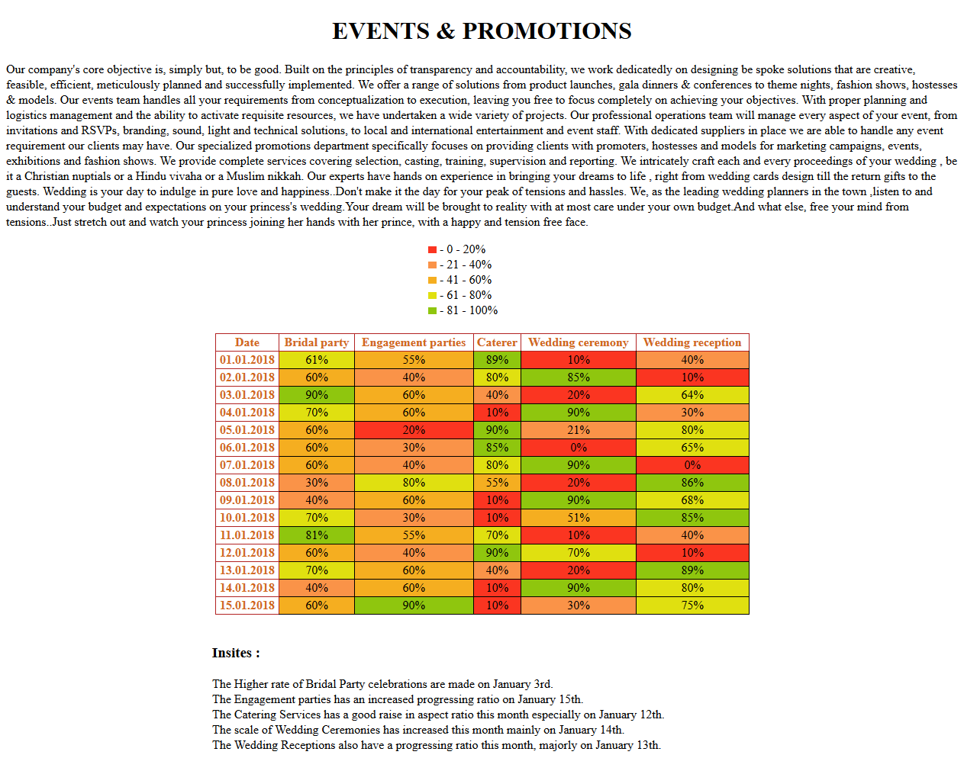  
  
Sample Screenshot 2 :  
  
